**Problem Statement:**

megaCart is an online shopping application, where users can buy various products based on their liking. In this application, the user needs to login to execute the user stories.

Following are the user stories :

* login : Consists of a simple form, which can be used to validate username and password and populate appropriate error message on the screen.
* sign-up : Consists of a simple form, which can be used to register them and populate appropriate error message on the screen.
* main : Would display categories of items available in the online shopping application, and the user can select the item which can be added into the cart.
* buy-item : Would display the list of items added in the cart by retrieving the associative array from the localStorage.

**Software’s Required:**

* Editor (Visual Studio Code IDE recommended)
* Browser (Google Chrome recommended)

**Note:** Follow the steps mentioned at the beginning of the course to install the required software.

megaCart: Details of the web pages

**Pages:**

* login.html
* sign-up.html
* main.html
* buy-item.html

Let us have a glance over the requirements which must be implemented stepwise.

1. **login.html**:

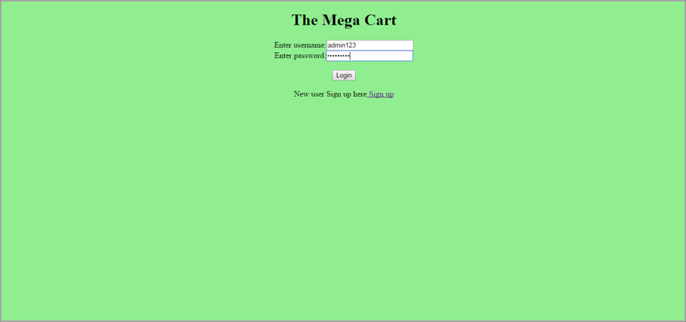

It will contain:

* Heading: The mega cart
* username: text field
* password: password field
* link for sign up

Implement the following logics on this page upon the click of the login button

* If the user is new to the web app, he needs to sign up. The signup link will navigate to sign-up.html (explained in step II), and you to need to implement the below-mentioned validations.
* Validate that username is the one that was saved during sign up.
* Validate that password is equal to the password that was saved during sign-up.
* Both fields are mandatory.

If both the validations are successful, do the following:

* Store username in localStorage
* Navigate to main.html

Else, show an alert asking the user to enter valid data

**HINT**: DOM API- to access text value, JSON - JSON.parse(localStorage.getItem()),JSON.stringify(localStorage.setItem( ), BOM location object

2. **sign-up.html**

This page will have a SignUp form consisting of the following details:

* Username
* Email
* Mobile
* Password
* Confirm password
* SignUp button

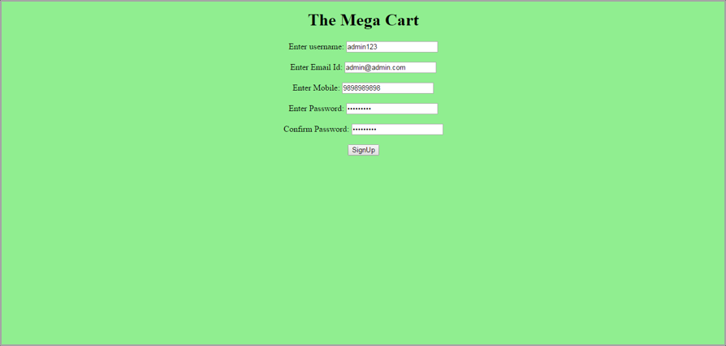

Implement following validations for the fields when button SignUp is clicked

1. Validate that username has minimum length 6 and maximum length 10.
2. Validate that email value contains a string followed by @ followed by string and dot(.) followed by a string.
3. Mobile number should be exactly ten digits
4. Password should contain a digit, characters, and one special character
5. Confirm password should be the same as the password

On successful validations, username and password should be stored inside the localStorage (to be retrieved for login authentication) and navigate to main.html

< HINT: DOM API- to access text value, RegExp, JSON - JSON.stringify(localStorage.setItem()), JSON.parse(localStorage.getItem()), BOM location object>

3. **main.html**

This will display categories of items available in the online shopping application using <ul>

* clothing
* beauty and health
* footwear
* school bags

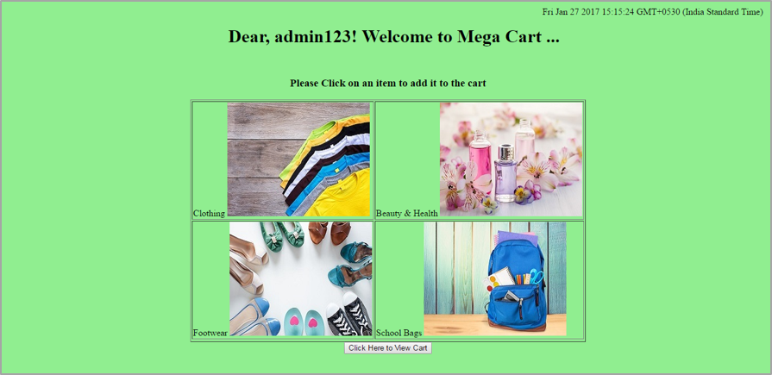

Each item is a clickable image. When the user clicks on any of the items,

* An alert should be populated on screen with an appropriate message as shown in the below screenshot.
* The item selected will be added as an object value inside an associative array with key 'items'
* Each item object will have properties: item name, image, cost, Days to deliver. (Cost should be a decimal value)
* Associative array 'items' will be stored in localStorage

Also, on the main page,

* There should be the heading with the content "Dear, <<username>>! Welcome to Mega Cart ...
* The Date will be displayed on the top right in the format: MMM DD, YYYY
* Logout link on the top left - click on which should clear localStorage and sessionStorage and redirect the user to login.html
* Button - **Click Here to View Cart** at the bottom. On click of the button, the user will be navigated to buy-item.html

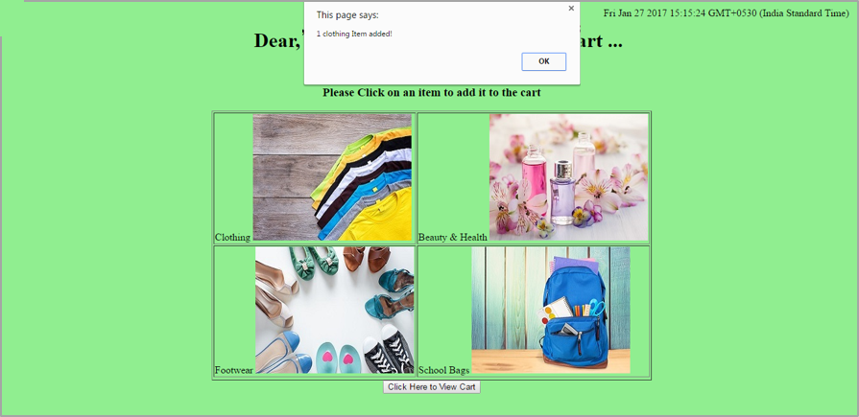

**HINT:**DOM API- to access text value, to manipulate DOM, JSON - JSON.parse(localStorage.getItem()),JSON.stringify(localStorage.setItem()), BOM location object, Date-getMonth(), getYear(), getDate(), String - substring(), concat(), Array.push(), Array.forEach()

4. **buy-item.html**

This will show the list of items added to the cart by retrieving the associative array from the localStorage.

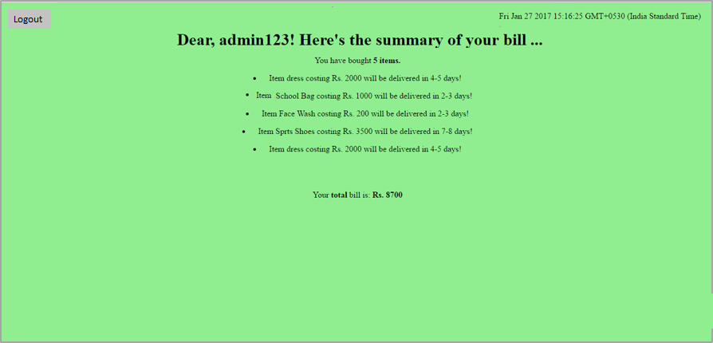

It will show

* item name, image, cost, Days to deliver in an unordered list <ul>
* total cost as rounded up value
* The Date on the top right in the format: MMM DD, YYYY
* Logout link on the top left - click on which should clear localStorage and sessionStorage and redirect the user to login.html

**Note:**

All the event handlers should be implemented using: addEventListener and code should be Linted appropriately.